# **Magic 8 Ball**

***C8051 Microcontroller***

Jeffrey Pistacchio

Christopher Pybus

Microprocessor Systems

05 December 2016

**Introduction**

The Magic 8 Ball has been a fun toy for many generations of children. This lab takes the idea of random answer to questions and applies the concept to a program on the C8051 Microprocessor. Furthermore this lab integrates the LCD and Keypad as input and output devices. Ultimately the program is designed to prompt the user to input the type of question (true/false, yes/no, day of the week, number) the user intends to ask and generate an applicable random answer. The entire decision flowchart can be seen below in Figure 1.

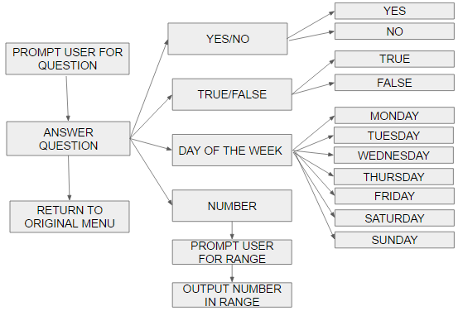

**Figure 1: Decision Flow Chart**

**Methods and Procedures**

The lab contained three parts. Part one involved writing a program that would prompt the user for the question type and run through the decision flow chart in Figure 1. Part two involved incorporating the LCD screen to display the output. Finally part three involved using the keypad to in take the input from the user. Each part was divided into two goals: a software goal and a hardware goal.

**Part 1**

**Part 2**

**Part 3**

**Results and Analysis**

Each section of the lab performed as intended. The Magic 8 Ball followed the flowchart in Figure 1, took input from the keypad, and outputted answers to the LCD Screen. The results of the lab can be seen in Table 1. The results were obtained by running through the different options and observing the displayed result.

|  |  |  |
| --- | --- | --- |
| **Table 1: Lab Results** | | |
| **Question Type** | **Expected Answer** | **Correct Output?** |
| Yes/No | Yes | Correct |
| No | Correct |
| True/False | True | Correct |
| False | Correct |
| Day of theWeek | Monday | Correct |
| Tuesday | Correct |
| Wednesday | Correct |
| Thursday | Correct |
| Friday | Correct |
| Saturday | Correct |
| Sunday | Correct |
| Range | # between upper and lower bound | Correct |

**Conclusion**

The team successfully accomplished all parts of Lab 6 by making several smaller programs that accomplished all the subgoals. Dividing the project into separate goals made the exercises significantly more approachable due to implementing the divide and conquer mindset. Each goal was simple enough that each group member could complete a goal by the time they came to class, and spend lab time debugging code and building hardware. Given more time the team would have liked to add enhancements, such as adding to the decision making flow chart or improving the randomness of the random number generator by using a continuous counter.